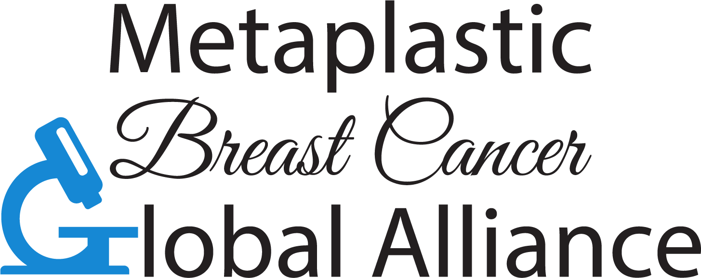
MpBC Global Alliance, Inc.
7 Bruce Road
Morganville, NJ 07751
admin@mpbcalliance.org
www.metaplasticbreastcancer.org

Dear Dr. _________________________________,
The MpBC Global Alliance, Inc. is a non-profit global organization operated by a community of diagnosed members and others supporting a patient with Metaplastic Breast Cancer. MpBC is considered to be a rare and complicated disease. While most of us are triple negative, treating us with TNBC protocols is considered ineffective and chances of metastatic disease are very high.
This Global Alliance is focusing on fostering better collaboration between noted oncology researchers, oncologists, and the patients who desperately need direction towards more effective targeted treatments. Your name was brought to our attention because of a patient who you have treated or a research publication that you were cited in. We are currently building our listing of knowledgeable doctors on our website, and would like to include you in this list.
If you are committed to supporting our grassroots effort to advance research and treatment for this rare disease, please sign below. This will allow us to document your contact information under the Knowledgeable Doctors section of our website, and will help us build a partnership bringing together researchers, oncologists, and patients. Page 2 of this document contains some additional information.
Please contact us if you have any questions or advice to offer us.
Sincerely,
The MpBC Board of Trustees
admin@mpbcalliance.org

Physician Name Signature:

Facility/Institution:

Date Signed:
*Please scan the signed approval letter and return by email to admins@mpbcalliance.org
*Please scan the signed approval letter and return by email to admin@mpbcalliance.org

Metaplastic Breast Cancer Global Alliance
www.mpbcalliance.org
Knowledgeable Doctor Expectations & Guidelines
October 2018

Be A Point of Contact in your area for Metaplastic Breast Cancer and Patient Advocate:

- Agree to be listed on our Knowledgeable Doctors List located on our website: www.metaplasticbreastcancer.org
- Remain current on the latest research studies, trials and treatment options for MpBC and support sharing this information.
- Be open to being recommended as a surgeon or oncologist to treat diagnosed patients.
- Understand the vital importance of fast tracking patients for treatments.
- Due to the aggressive nature of this breast cancer, assist those diagnosed with a scanning protocol that will detect disease progression early and will support treatment without a delay.

Provide Support to the Metaplastic Breast Cancer Global Alliance

The MpBC Global Alliance Inc. Board of Directors/Trustees welcomes your guidance in areas that will help us advance our goal of assisting our diagnosed members and those that care for them. Please do not hesitate to recommend other qualified physicians to join us in supporting the advancement of research and treatment options for those affected by this rare and aggressive breast cancer.

